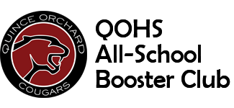
Grant Request Form

Date: ________________________
Name of Organization Requesting Funding: ______________________________________________
Sponsor/Coach Name: ______________________________________________________________
Sponsor/Coach Contact Information: ___________________________________________________
Dollar Amount Requested: ___________________________________________________________
Purpose for Requested Funding: ____________________________________________________________________________________________________________________________________________________________________________________________________________________________________________________________________________________________________________________________________

Person Presenting Request at Booster Club Meeting and Contact Information: _________________________________________________________________________________

In return for funding approval, we agree to provide volunteers for concessions and assist with the annual Mulch Drive. Please provide the main point of contact for providing these services and their contact information. _________________________________________________________________________________

Please Note: Athletic teams must seek the approval of the QOHS Athletic Director and Clubs/Organizations must seek the approval of the QOHS principal prior to submitting request to the Booster Club. Please have the appropriate approval person sign and date on the line below:
Signature: _____________________________________________Date:_______________________

Return completed form to: Kate Carter at the QOHS Booster Club Mailbox. Questions can be emailed to her qohsboosterprez@gmail.com .The Booster Club Executive Secretary will contact the person who presented the request at the Booster Club Meeting with our decision within 24 hours.

Booster Club Response: Funding: Approved ____ or Denied _____
If denied, reason: ___________________________________________________________________

